1. **MODIFY any SOFT link and observer original?**

* Text

  Description automatically generatedFirst, we make a folder called link and then create two text files inside it, namely, 1.txt 2.txt using the touch command.
* Now, create a symbolic or soft link using the following command.

* We can see the inode number as well to confirm

* When we modify the linked file(3.txt) we can see the modification reflected in in the original file (1.txt)

1. **MODIFY original file of SOFT link and observe?**

* When I modified the original file the soft link also reflected the same changes

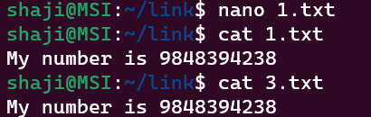

1. **Remove any SOFT link and observer original?**

* The removal of the soft link didn’t change anything in the original file.

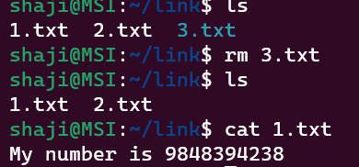

1. **Remove original file of SOFT link and observe?**

* The soft link becomes inaccessible when we delete the original.

1. **Modify any hard link and observe original**

* Text

  Description automatically generatedFirst, we created a hard link between two files file1.txt and hardlink.txt

* When we modified anything in the hardlink.txt it reflected in the original file.

1. **Modify original file of hard link and observe**

* 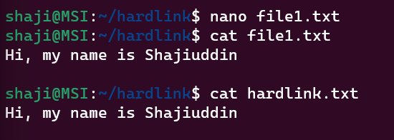When we modified the original file1.txt, it reflected the modifications in the hardlink.txt

1. **Remove any hard link and observe original**

* There was no impact on the original file1.txt

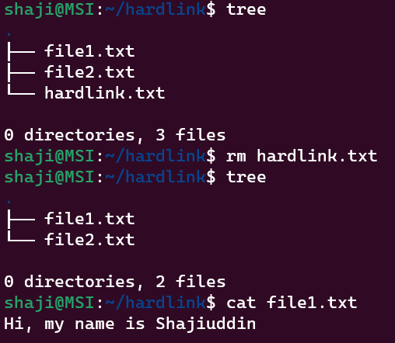

1. **Remove original file of hard link and observe**

* The linked file is still accessible Text

  Description automatically generatedwith no impact on the linked file.

1. **Comparison among soft & hard copy**

* Soft Links are invalid once the source or parent file is deleted.
* Soft link is just a link that points to the original file yet with different inode numbers and permissions.
* The soft link is like a shortcut to a file. If you remove the file, the shortcut is useless.
* If we remove the soft link, the original file will still be available.
* Hard Link and source file have the same inode number and permissions.
* If we change the permissions on the source file, the same permission will be applied to the hard link file as well.
* If we change the permissions on the source file, the same permission will be applied to the hard link file as well.

**Differences between “wget” & “curl” commands**

* wget and curl are both command-line utilities used to download files and web pages from the internet. However, they have some key differences in terms of their features and functionality. Here are some of the main differences:
* wget can recursively download files, which means it can follow links within a web page and download all linked files. curl cannot do this by default, although it can be scripted to simulate this behaviour.
* curl supports many more protocols than wget, including FTP, SMTP, POP3, and more. wget primarily supports HTTP and HTTPS.
* curl is more flexible and customizable than wget. It supports many more options and can be used for more complex tasks, such as sending data to a web server using different methods (e.g. POST, PUT, DELETE).
* wget is installed by default on most Unix-based systems, while curl may need to be installed separately.
* In summary, wget is a simple and reliable tool for downloading files from the web, while curl is a more powerful and flexible tool that can be used for a wider range of tasks.

**SCRIPTS**

1. **Write a script to print the date and redirect it to output.txt?**

1. **Make a folder using the date as the name**



1. i) Create a bash script to print the local time, date, username of your system, and your current path.

ii) After printing, redirect the output into a file called output.txt

iii) Insert output.txt into a new directory, where the directory name is the current timestamp.

1. **Create a bash script to execute the date every 2 minutes once on Saturdays only**



1. **Take a backup of a folder every month twice**



1. **Print the count of the number of files in a folder & print the output in a file called count.txt**

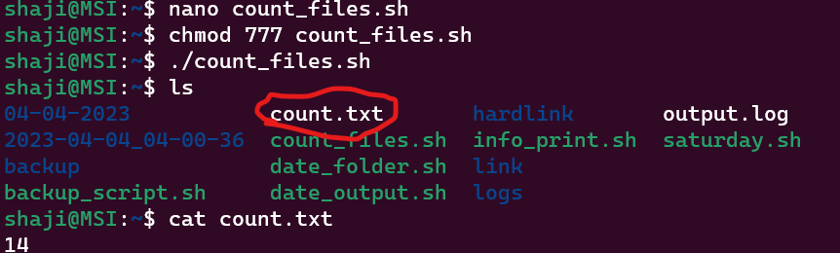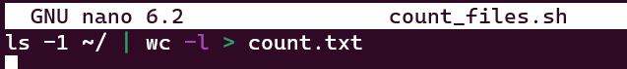

1. 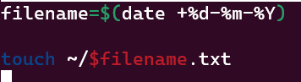**Create files dynamically everyday at 12 AM where the file name is a date**



**Crontab scripts labs**

1. **Write a script to print the current directory and username and redirect it to a file called output.txt**

1. **Create a file with the current timestamp as its name inside a folder with the current date as its name?**

1. **Create a bash script to print the local time, date, username of your system, and your current path and redirect the output into a file called output.txt. Insert output.txt into a new directory, where the directory name is the current timestamp.**

1. **Write a script to print the count of the number of files in a folder and redirect the count to a file called count.txt**

1. **Create a bash script to execute the date every 2 minutes once on weekends only**



1. **Take a backup of a folder daily twice**

